

Department of Computing and Information Sciences
Semester II 2025-2026
CSIS3103 – User Experience Design

Skill Swap Application

Table of Contents
1. Project Description 3
2. Emphasize 3
2.1. Personas 3
2.2. User Story 4
2.3. User Journey Map 4
3. Define 5
3.1. Problem Statement 5
4. Ideate 5
4.1. Competitive Audit 5
5. Prototype 7
5.1. Low Fidelity Prototype: User Flow Chart 7
5.2. High Fidelity Prototype: User Interface 8
References 12

Project Description
Our Skill Swap application is designed to make student life easier by enabling peer-to-peer learning and collaboration. It allows students to seek help from their peers by exchanging expertise across areas such as academic courses, programming skills, and other practical competencies. In addition to academic support, the platform also encourages social interaction by helping students connect, build friendships, and share skills beyond the educational context. Through this exchange-based system, students can both teach and learn from one another, fostering a supportive and collaborative learning community.

Emphasize

Personas
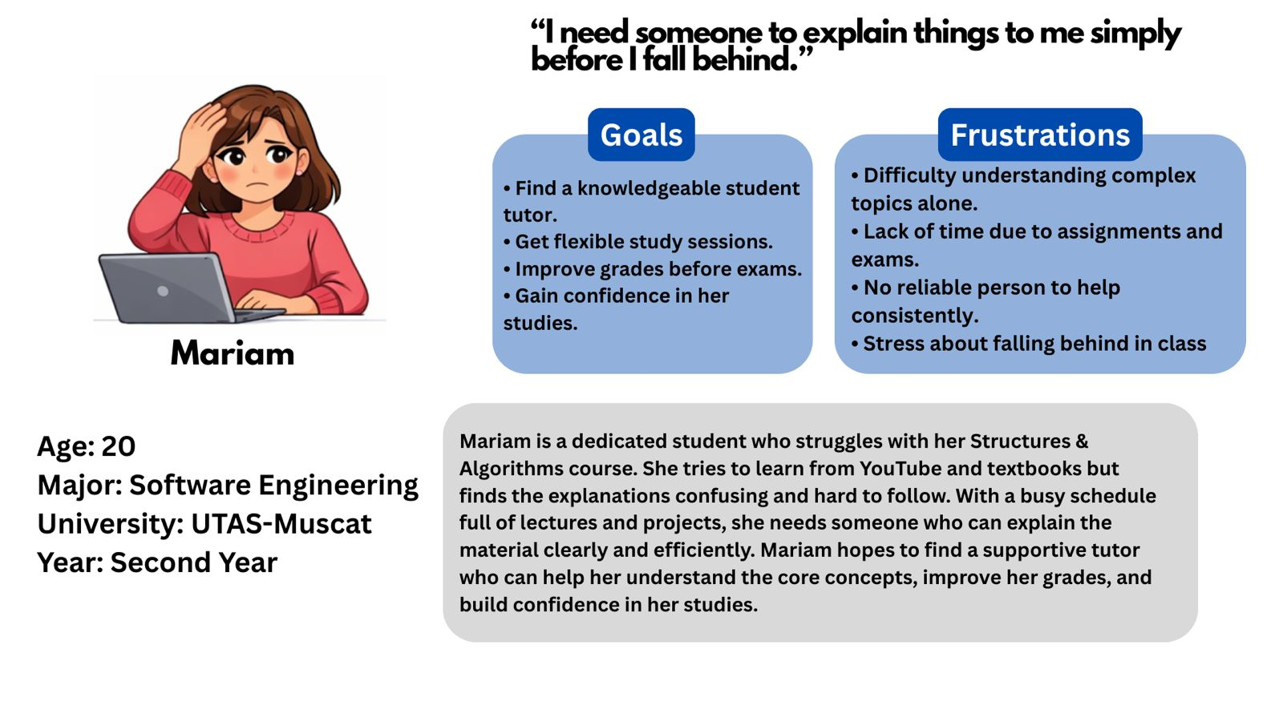
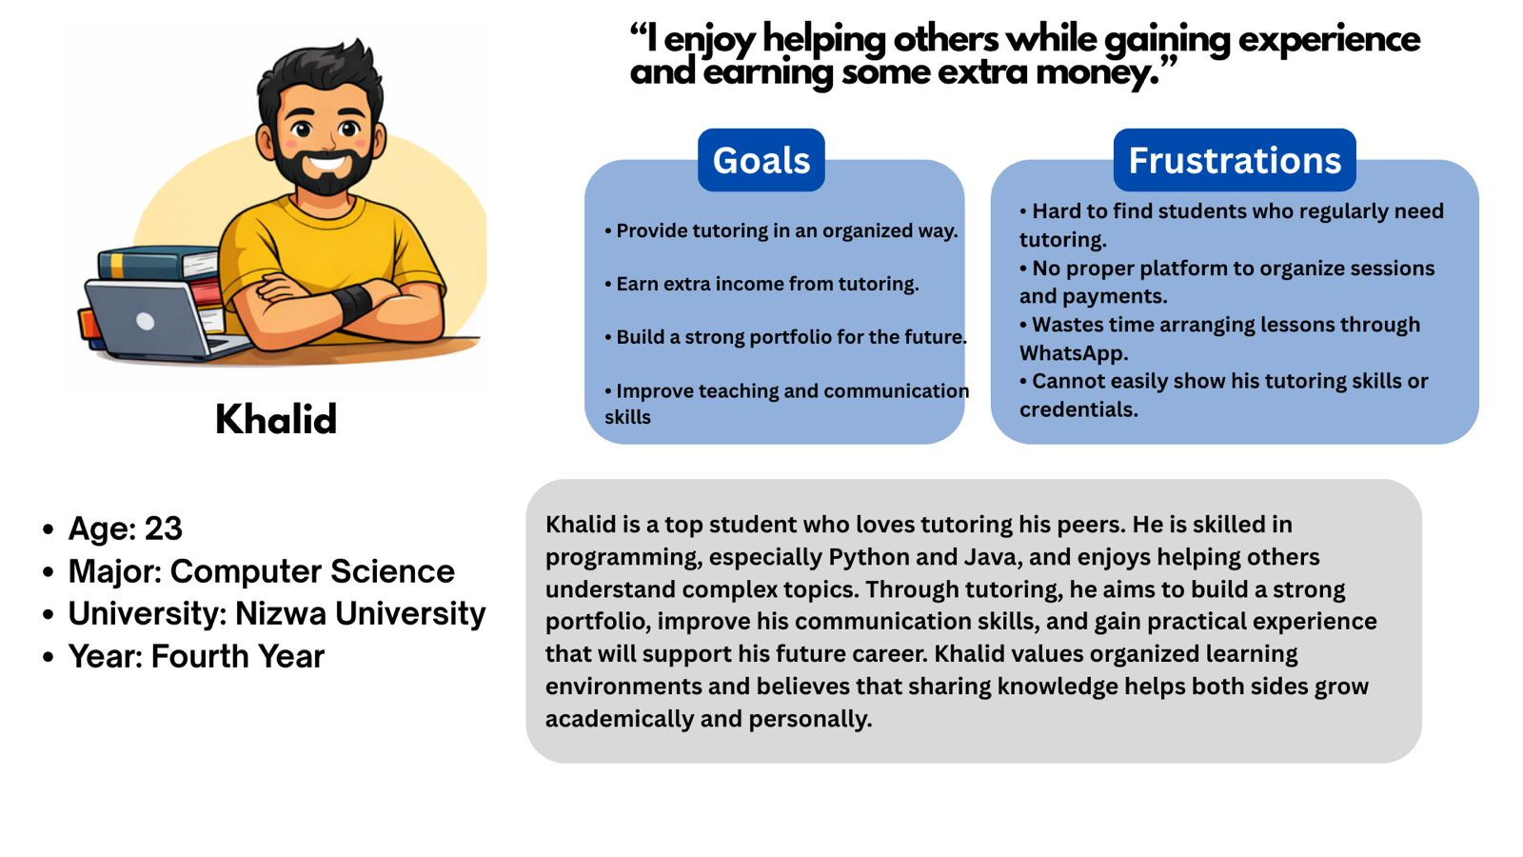
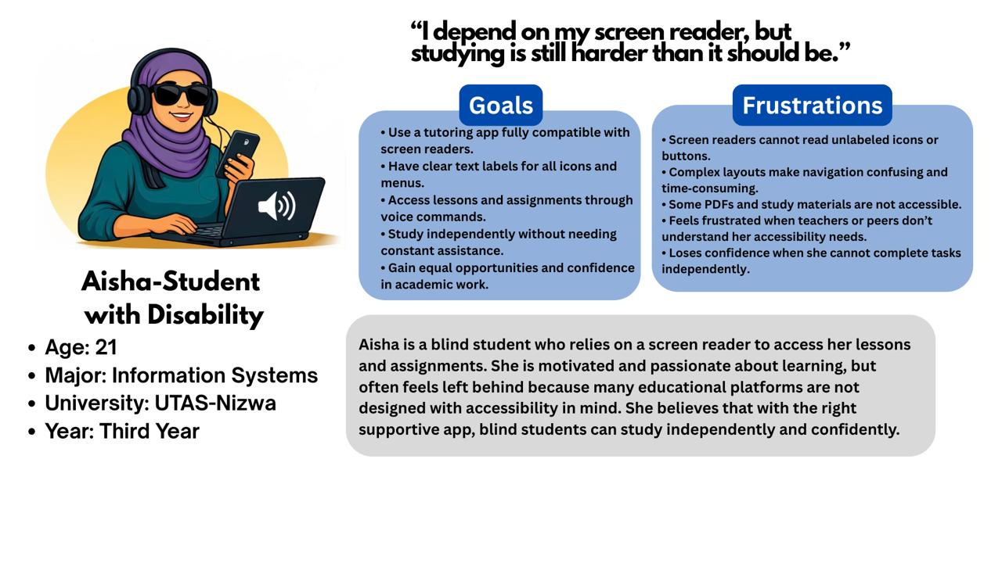

User Story
- As a second-year Software Engineering student (Mariam), I want a simple and clear way to understand complex topics in Structures & Algorithms with flexible support, so that I can keep up with my studies, improve my grades, and feel more confident before exams.
- As a skilled Computer Science student and tutor (Khalid), I want a platform where I can organize tutoring sessions, connect with students, and showcase my skills so that I can earn extra income, build my portfolio, and improve my teaching experience.
- As a visually impaired Information Systems student (Aisha), I want a fully accessible tutoring app with screen reader support and voice-based navigation, so that I can study independently, complete assignments efficiently, and feel confident in my academic performance.

User Journey Map
Actions | Opens app, explores landing screen | Logs in / signs up | Creates or edits a profile | Searches or browses tutors/services | Select a tutor or create a service | Chats, schedules, and conducts sessions | Provides feedback after the session
Task  List | • Read  /Listen to the welcome message. •Navigate via touch/voice.  • Click Get Started/Login. | • Enter credentials.  • Social login.  •Account verification. | • Add bio, skills.  • Set availability.  •Choose preferences & accessibility. | • Search (text/voice).  • View recommended services. | • Review profiles.  • Apply filters.  •Book sessions. | • Send messages  • Ask/answer questions  •Confirm sessions | •Write/record feedback.  • Get suggestions.  • Rate services.
Feeling  Adjectives | Curious, hopeful, motivated | Neutral, focused | Engaged, slightly overwhelmed | Slight stress, relief | Confident, hopeful | Engaged, sometimes anxious | Reflective, satisfied, sometimes critical
Improvement Opportunities | • Strong value proposition.  • Voice onboarding.  • Simple navigation. | •Google/Apple login.  • Fewer fields.  • Voice login.  • Clear error feedback. | • AI-assisted suggestions.  • Auto-skill suggestions.  •Accessibility settings. | • Smart suggestions.  • Personalized recommendations.  • Best-match highlighting.  • Filters.  • Voice shortcuts. | • Skill badges.  •Personalized recommendations.  • Accessible layout. | •Quick replies. • Clear chat UI. •Reminders.  •Voice support. | • Easy feedback UI.  • AI insights.  •Personalized recommendations.

Define

Problem Statement
- Mariam is a second-year Software Engineering student struggling with Data Structures & Algorithms, who needs a reliable way to find a knowledgeable peer tutor who can explain concepts and offer flexible session times, because she feels stressed about falling behind, has a busy schedule, and finds self-study through YouTube and textbooks confusing.
- Khalid is a fourth-year Computer Science student and peer tutor who needs an organized platform to find students, schedule sessions, and manage payments because he wants to earn extra income, build his portfolio, and avoid wasting time.
- Aisha is a third-year Information Systems student with a visual impairment who relies on a screen reader and needs an accessible learning platform with clear navigation and labelled content because inaccessible materials and complex layouts make studying difficult, reducing her independence and confidence.

Ideate

Competitive Audit
Competitive Audit Goal | We want to understand how existing platforms enable or fail to enable peer-to-peer skill exchange, identify market positioning strategies, and uncover gaps where we can make a dedicated skill-swapping app that can provide better matching, trust, and learning experience.
Key Competitors | Skill Swap Hub:  A peer-to-peer skill exchange app focused on connecting users who want to trade skills directly without money. | Reciproc8:  A reciprocity-based platform emphasizing mutual value exchange, where users offer and request help/services within a community. | Skill Match:  A matching-focused app that connects users based on complementary skills and learning needs using profile-based discovery.
Competitors product type and quality | Skill exchange mobile app, medium-quality UX with basic functionality. | Community reciprocity app, medium–low UX maturity. | Matching-based skill exchange app, medium-quality UX with focus on profiles.
Competitors position in market | Direct skill barter platform. | Community-driven help & exchange ecosystem. | Skill-based matchmaking platform.
Competitors talk about themselves | “بادل مهاراتك مع الآخرين بسهولة” (Exchange your skills بسهولة).” | “Give and receive help in a trusted community.” | “Find the perfect match to learn and grow.”
Strengths | -Simple concept: direct skill-for-skill exchange.  -Easy onboarding and quick listing of skills.  -Clear value proposition (no money involved).  -Mobile-first approach.  -Localized/community-friendly usage. | -Strong community and reciprocity mindset.  -Encourages trust and repeated exchanges.  -Flexible (not limited strictly to skills).  -Focus on mutual benefit rather than strict matching.  -Potential for social bonding. | -Matching-oriented approach (more scalable idea).  -Profile-based system improves personalization.  -Focus on compatibility between users.  -Cleaner structure compared to generic exchange apps.  -Potential for algorithm-driven growth.
Weaknesses | -Limited matching intelligence (mostly manual search).  -Weak trust/verification system.  -No structured learning or progress tracking.  -May struggle with user retention. | -Not specialized for skill exchange (too broad).  -Weak UX/UI clarity (can feel confusing).  -No strong matching or discovery system.  -Lack of structured skill categories.  -Engagement depends heavily on an active community. | -Matching may feel shallow (based only on profiles, not behaviour).  -Limited real-time interaction tools.  -No clear incentive system (credits, rewards, etc.).  -Trust and verification mechanisms are minimal.  -Still lacks strong community features.
Gaps | - No intelligent, fast matching system (AI-based or intent-based).  - Weak trust layer (no strong verification, ratings, or proof of skill).  - No structured learning journeys (progress tracking, milestones)  - Limited real-time interaction (chat, video sessions, scheduling tools).  - Weak skill validation (no portfolios, tests, or peer endorsements).  - No strong network effects design (communities, groups, niche hubs).
Opportunities | - Build a modern UX skill-swap platform.  - Add skill verification system (projects, peer validation, portfolios).  - Design fast matching (instant skill exchange requests).  - Add community loops (groups, challenges, skill missions).

Prototype

Low Fidelity Prototype: User Flow Chart

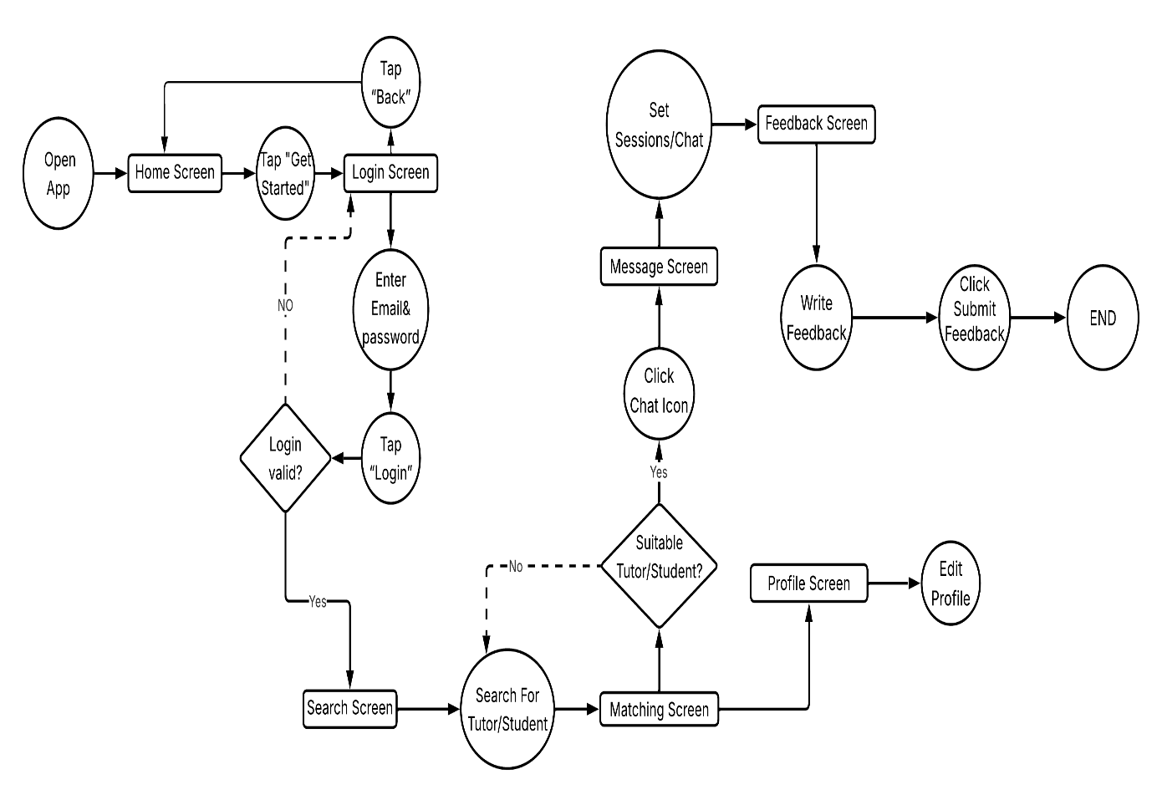

High Fidelity Prototype: User Interface
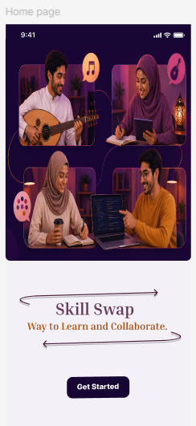
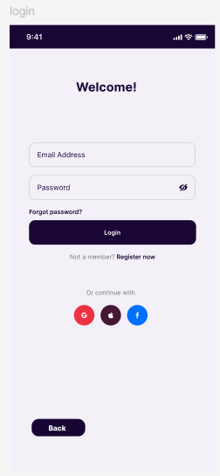
Figure 1- Home Page Figure 2- Login Page

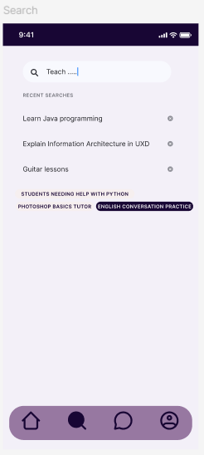
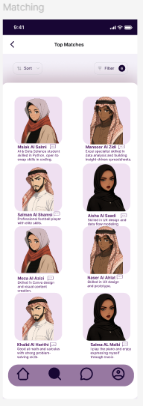
Figure 3- Search Page Figure 4- Matching Page
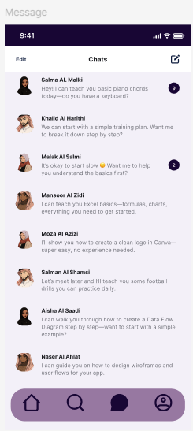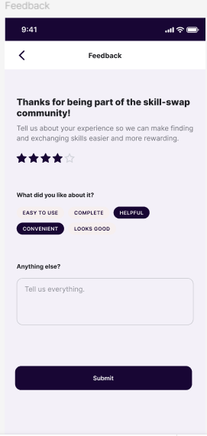
Figure 5- Message Page Figure 6- Feedback Page
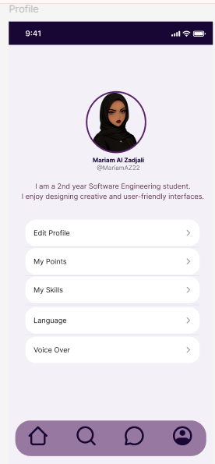
Figure 7- Profile Page

References

https://www.figma.com/design/WpYhHhu1Qb5KG5zBSYu0jD/Skill-swap-app?t=tfI28XM3TuB0bOWf-1
SkillHub. (2024). SkillHub: Learn, earn, and share skills online. Retrieved April 23, 2026, from https://skillhub.com/
Barter Bloc. (2025). Barter Bloc: A peer-to-peer skill exchange platform using credits. Retrieved April 23, 2026, from https://www.barterbloc.io/
SkillMatch. (2025). SkillMatch: Connect, learn, and teach through skill exchange. Retrieved April 23, 2026, from https://www.skillmatch.tech/

